Creating Microservices for account and loan

In this hands on exercise, we will create two microservices for a bank. One microservice for handing accounts and one for handling loans.

Each microservice will be a specific independent Spring RESTful Webservice maven project having it's own pom.xml. The only difference is that, instead of having both account and loan as a single application, it is split into two different applications. These webservices will be a simple service without any backend connectivity.

**Solution:**

1. **Account Microservice**

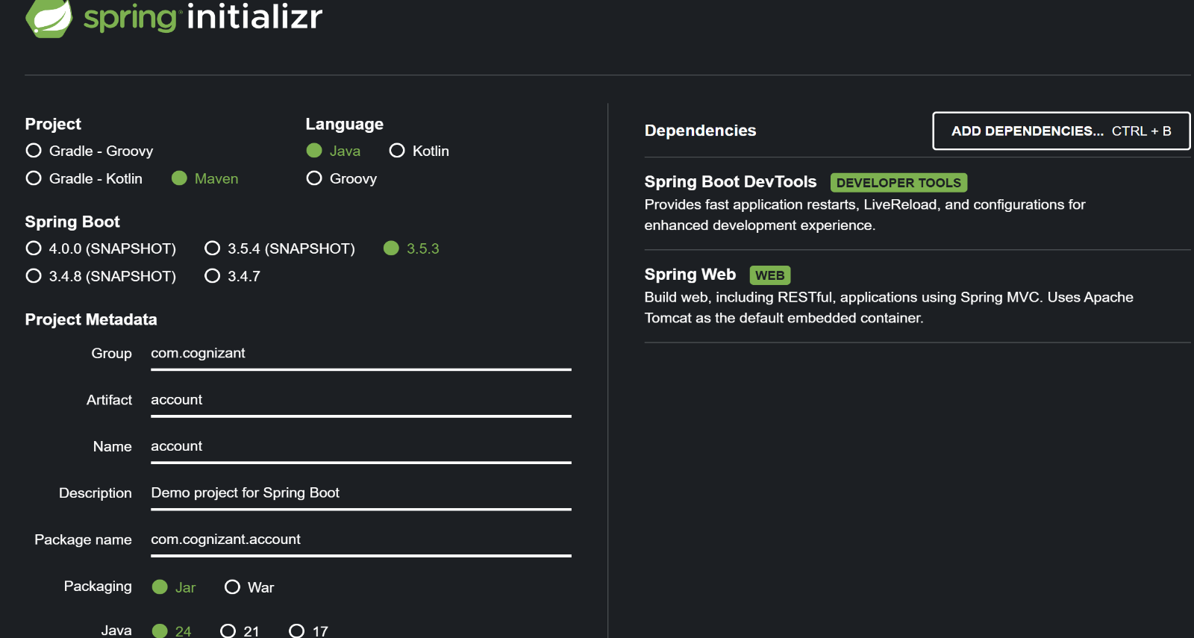Step 1: **Generating Spring Boot project** with **spring-initializr**

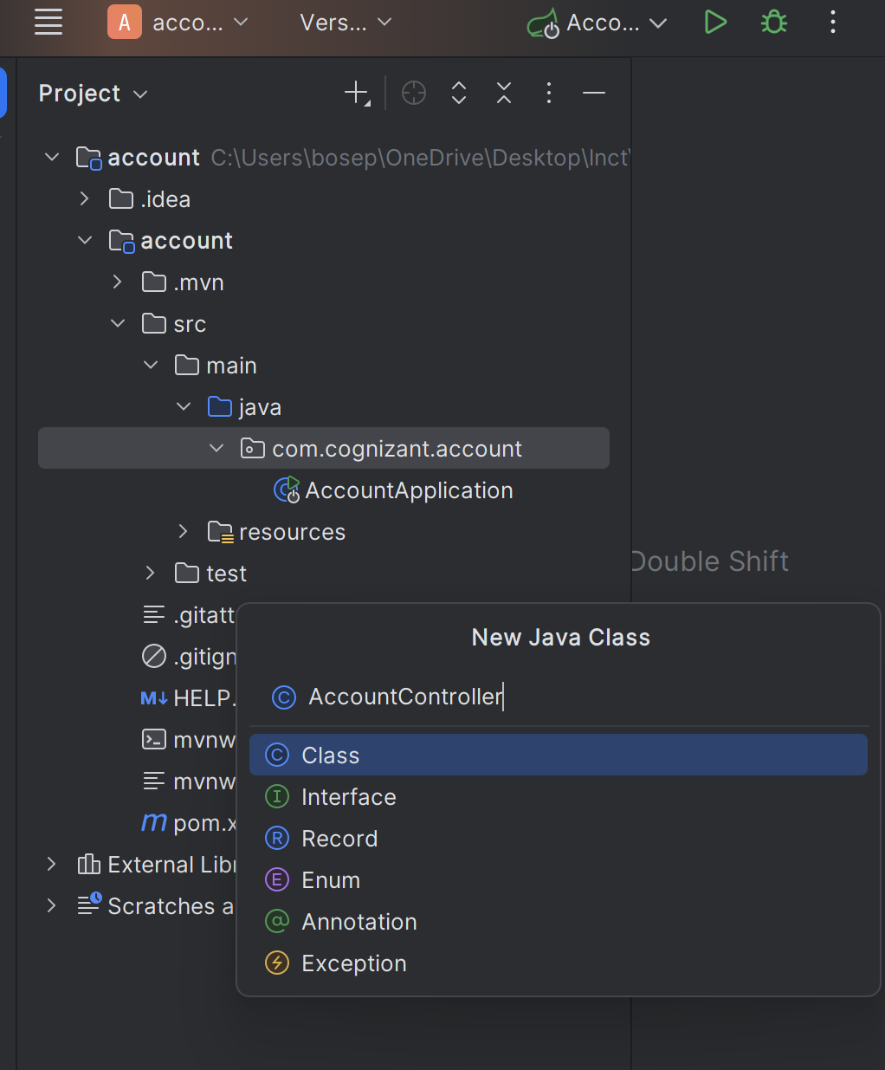**Folder structure in IntelliJ** IDE is as follows for implementing the controller.java class:

**Step 2**: **Implementing** the **AccountController.java** class with the required specifications:

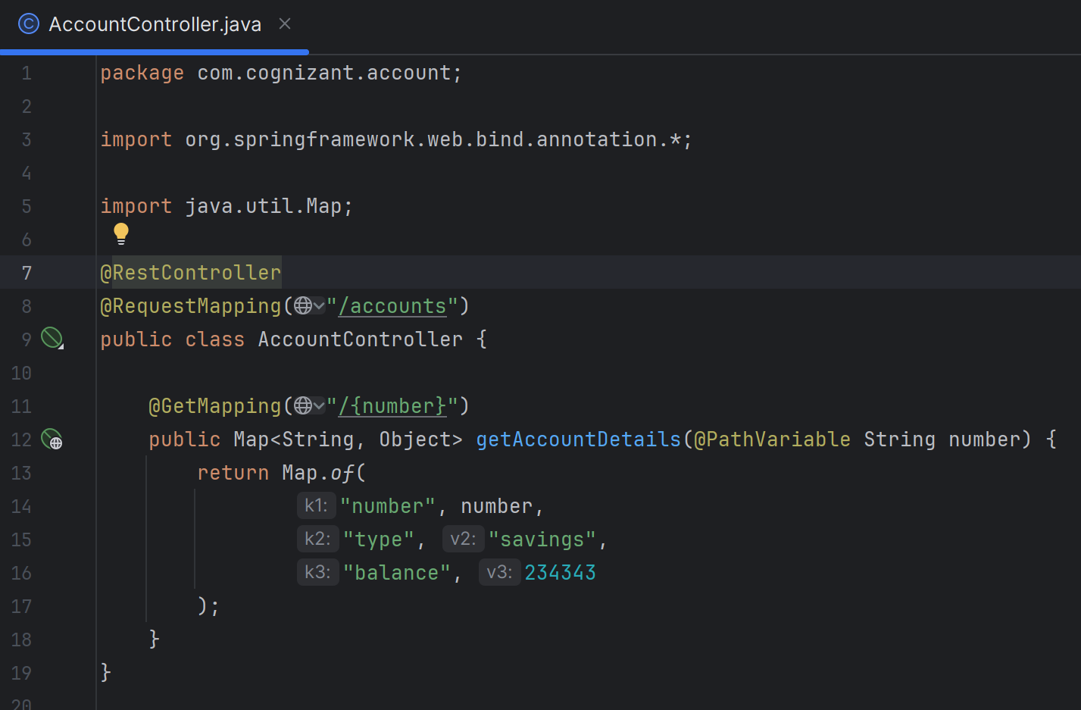

**Step 3**: Run the Application i.e. **Run 'AccountApplication.java'**.   
 The **output** of the above code is shown below via **Postman** for   
 url: <http://localhost:8080/accounts/9098798797432> with GET-request

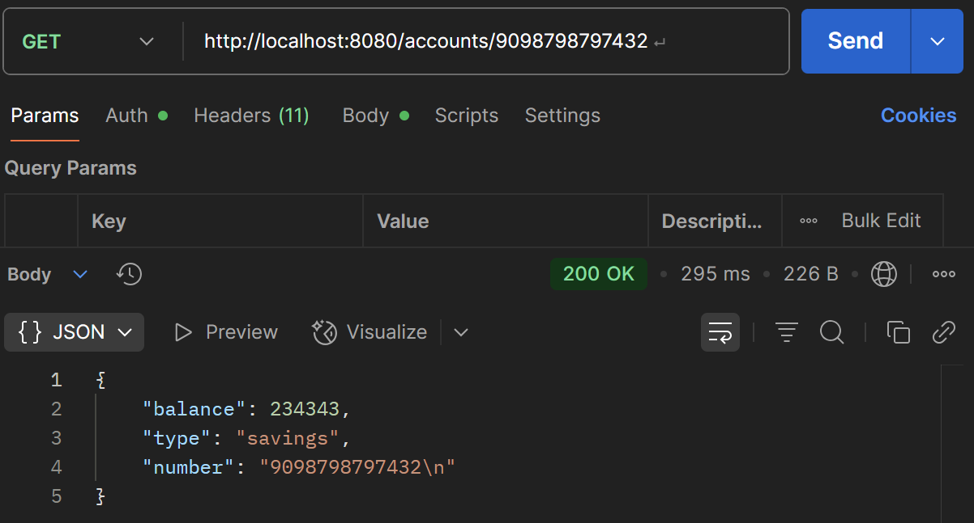

__________________________________________________________________

1. **Loan Microservice**

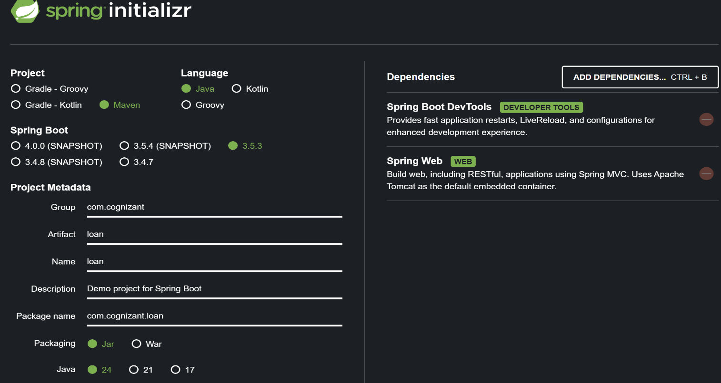**Step 1**: **Generating Project** via **Spring-initializr**

Extracting the above in IntelliJ IDE thereby creating a new folder named **loan** and proceeding withthe implementation of controller class.

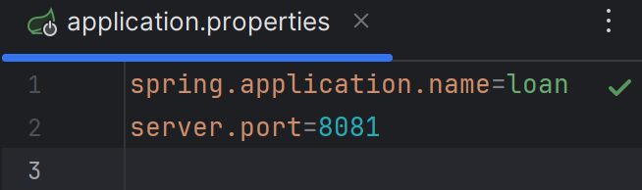Step 2: **Setting** a Different **Port** in **application.properties** file with code 🡪 server.port = 8081

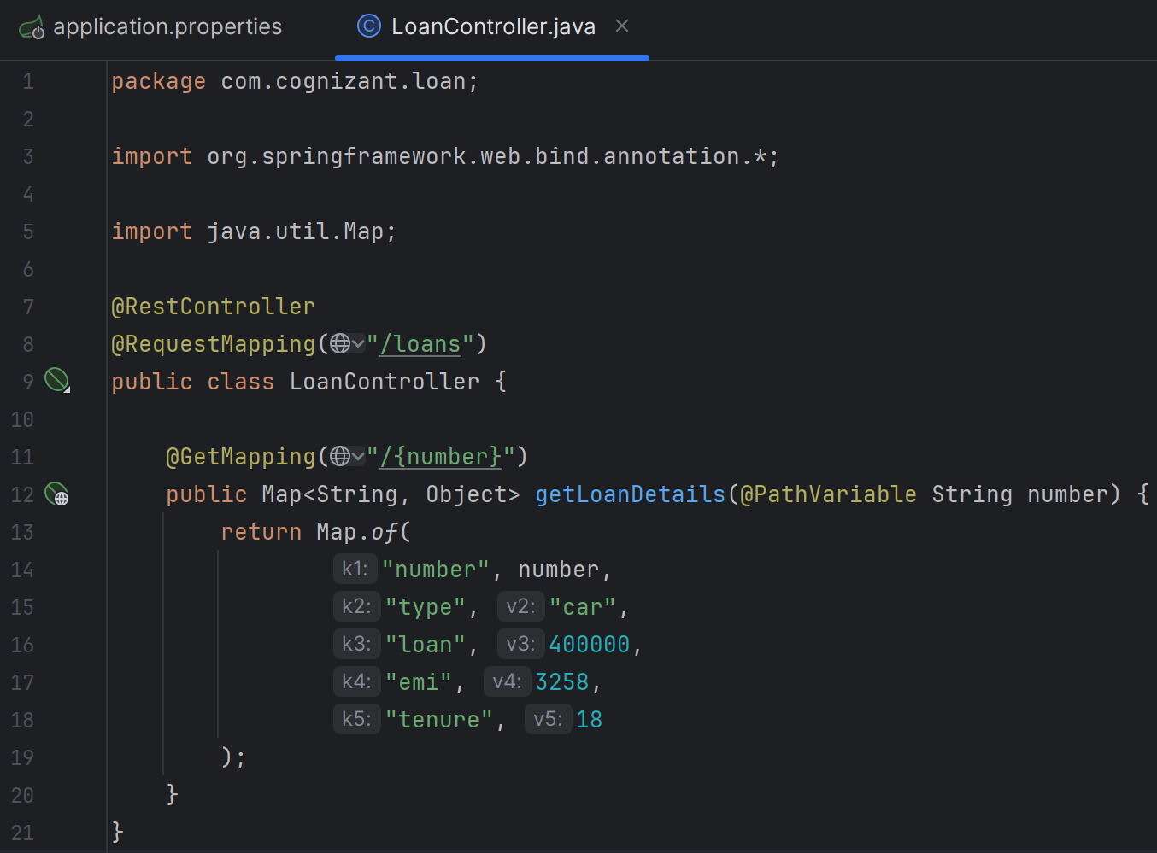**Step 3**: **Creating** the **LoanController.java** class in src/main/java/com/cognizant/loan folder

**Step 3**: Run the Application i.e. **Run 'LoanApplication.java'**.   
 The **output** of the above code is shown below via **Postman** for   
 url: <http://localhost:8081/loans/9098798797432> with GET-request

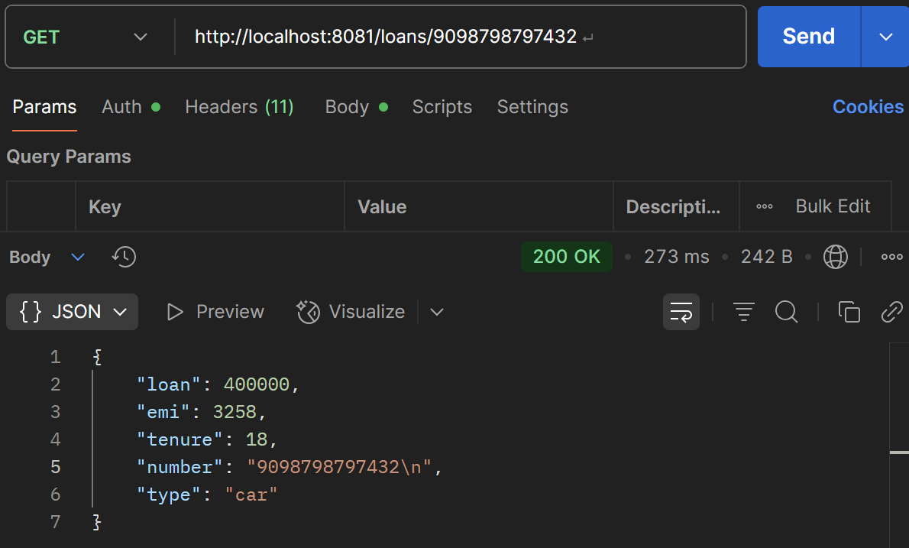

Therefore, now we’ve two microservices running on different ports.

_________________________________________________________________________________